Lesson 01 XAS Resource Workbook

**Vocabulary Words:**

**Photoelectron:** Electrons emitted from an atom through the process of absorbing electromagnetic radiation

**Core-hole:** The vacancy left behind in a core shell of an atom after an electron has been excited.

**Electronic Transition:** A change in electron energy level. These transitions can be mediated by either the emission or absorption of photons, i.e., quanta of electromagnetic radiation.

**Exercise:**  Below is a diagram of the energy levels in an atom. The up and down arrows represent spin-up or spin-down electrons, and the dashed line represents the Fermi energy. There are three distinct domains: occupied states, unoccupied discrete states, and continuum states. Shade them in using the colors blue, green, and red, respectively.

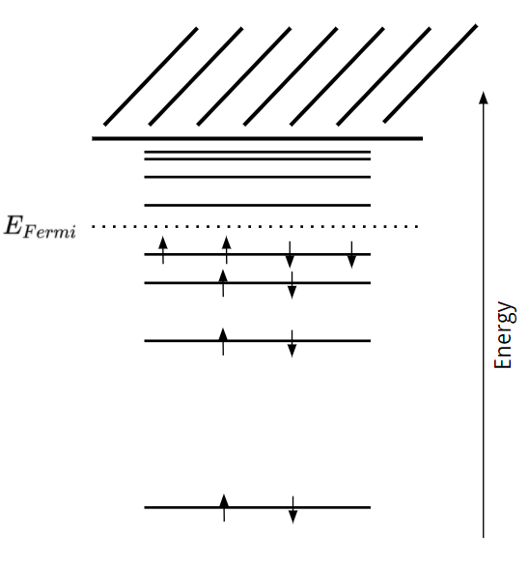

**Exercise:**  Below is a depiction of famous scientist Albert Einstein. Please color him in.

